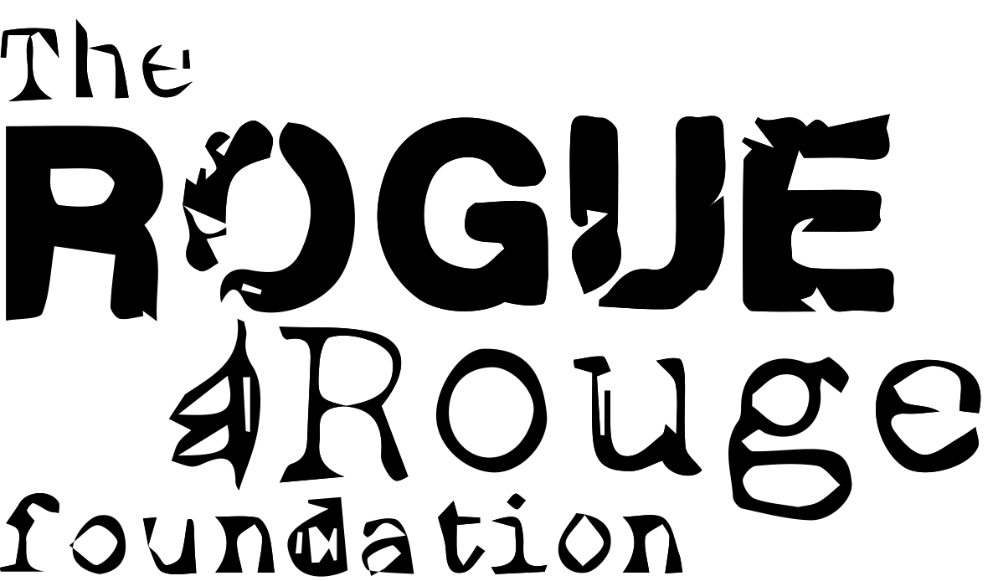

Primary Prevention Program

Empower & Encourage: Expression & Awareness

2015

The Secret Gift

Weekly Outcomes

Week One: Introducing the Gift

Themes
Week one introduces the students to the main facilitator and what the 5 week program will entail as well as outlining objectives and purpose of their participation. During the first session participants will get the opportunity to look at where they are now and gain a different perspective on themselves and take a look inside, discovering their strengths and gifts.

Aims of the session
1. Introduce the secret gift
2. Develop a relationship with facilitator
3. Establish group dynamic
4. Identify their personal strengths and skills
5. Self Reflection through guided meditation

Week Two: What’s my personal gift?
Themes
Week two will begin the exploration of the participant’s inner world. Students will be asked to reflect and recognize archetypal characters of influence. We will explore personal values and discuss positive characteristics.

Aims of the session
1. Reflect on characteristics and how they affect us
2. Look at how we can positively overcome, and embrace challenge
3. Continue to build on the strengths and skills established in session 1

Week Three: Self Discovery
Themes
Week three is where we begin to delve deeper. The students will be asked to prepare themselves for a major ordeal ahead of them. What can we do when a major event arises? How do we use our strengths to get the best possible outcome for us? Students will be given an opportunity to develop an approach that is based on their strengths.

Aims of the session
1. Prepare students for a major challenge
2. Think of ways to use newly discovered strengths to turn them
3. Build resilience and provide a safe space to look at how challenges might look from a new perspective.

Week Four: Utilising my gifts
Themes
Week four students will continue to build on their newly identified strengths. Students will be asked to honour and acknowledge themselves and each other, in order to cultivate deeper reflection and appreciation.

Aims of the session
1. Develop confidence
2. Have their efforts rewarded through recognition
3. Empower individuals
4. Gain belief in personal strengths

Week five: Celebration
Themes
With these newly recognized skills, participants will be encouraged to reflect on where in their life they might be able to utilize these skills. When can they use it, how will they use it etc. students will celebrate success within the group and will be encouraged to carry this with them throughout their life and into their next adventure. Final debrief and group closing to finish.

Aims of the session
1. To empower students to use their skills and strengths to overcome any challenges they face in life.
2. To witness, encourage and congratulate students for their commitment and persistence.
3. To provide the opportunity for discussion around student’s achievement and self- awareness.

About the Program

The Secret Gift is based on a strength based and preventative approach to supporting young people. It draws on a creative and narrative approach to encourage people to better understand their identities.

The Secret Gift incorporates the use of several different art activities, different art mediums and narratives to explore and express the ideas young people have about themselves. The five weeks are designed to give young people the opportunity to explore their strengths but also to look at how our strengths can be utilized in certain aspects of our lives. Through this understanding participants can better know themselves and indirectly prepare themselves for challenges that this age group can face.

Dr Morrison writes about restorative justice and behaviour management and recognizes that “Early intervention has been advocated as the most appropriate way to prevent bullying”. Each group comes with a different set of challenges the participants may be facing, for example: behaviour problems, bullying, social skills, self-harm etc and as a group facilitator I use the group dynamic as a platform to inform each weeks theme. The underlying principle is to transform challenges whilst encouraging participants to take a look at their strengths and build on these characteristics so that they identify with them as their own and embed them into their being.

Secret Gift encourages that as young people experience events in their life they can share their story and perspective, to become aware and learn.

Mission: Every young person will understand their true potential, breakthrough limited conditioning and belief systems to pursue their dreams and develop an individual purpose in life.

Vision: To create a generation of empowered self-aware individuals that question status quo and become curious towards social conditioning and understand their voices paves and shapes the future.

Objectives
1. Facilitate a positive space to allow young people to develop their own purpose
2. Break through limited belief systems that prevent young people from thriving
3. Instil a community conscience amongst the group

Time
The program will run for 5 weeks, each session allowing for 1.5 hours. Each week will have a unique theme with unique objectives. Each week will carefully and accurately prepare the student for the following week.

Demographic
This program is specifically designed for grade 7 students (12-13 year olds)

Delivery

This program is an exclusive creation of The Rogue & Rouge Foundation, and will be delivered by Lucille Downing. Lucille Downing is a Rogue and Rouge team member and art therapist. Lucille will apply art therapy coupled with narrative style activities to provide an encouraging space for participants to further explore themselves and have some fun! Lucille works in a way that is holistic.

“I offer a unique and holistic approach to therapy that is aimed at body, mind, soul and heart and tailored to each individual. I work with the individual and what they bring to empower them to recognize their strengths and build on those by creating and utilizing different artistic mediums. Art therapy supports the individual to reflect and allows them to reach new perspectives and a new sense of self-awareness. It is supportive and tangible and utilizes more than ones verbal intelligence” - Lucille Downing

Program Cost: $2000.00

About The Rogue & Rouge Foundation

The Rogue & Rouge Foundation is an association that helps decrease mental health challenges within our community, as well as diminish the stigma placed upon these conditions. The Foundation aims to do this in two ways; firstly, through education and youth engagement and secondly, by providing financial assistance to those seeking various medical treatments through their journey of recovery.

Vision: Every young Australian is adequately cared for and supported.

Mission: To facilitate positive communities amongst Australian youth by educating them on healthy body image, creating peer support networks and guiding passions to increase self-worth and confidence. We also strive to provide financial assistance to individuals and families undergoing treatment mental health challenges.

About the Founder: Nicole Gibson

Nicole is committed to making a positive difference in the lives of young people. After overcoming mental health challenges as a young person, in particular anorexia nervosa, Nicole is channelling her energy into motivating other young people to be the best they can be. In 2011, Nicole established The Rogue & Rouge Foundation to reverse the stigmatisation of mental health, body image and self-esteem issues in Australia’s young people.

As the Foundation’s Chief Executive Officer, Nicole dreams that every teenager can look in the mirror and smile. Nicole is tackling the epidemic of low self-esteem by creating community outreach programs and working directly with schools, service providers and education departments in both central and remote parts of Australia. Nicole has recently completed her national youth motivation tour, 'Champions for Change', which has since seen her facilitate workshops at 300 schools and communities with 70 000 young people across Australia to encourage young people to champion change in their communities through the development of innovative solutions.
Ms Gibson was a finalist for Young Australian of the Year 2014, one of Australia’s top 100 most influential women, was appointed onto the National Mental Health Commission as the youngest every commissioner, named as one of Australia’s 2012 Young Social Pioneers and won The Pride of Australia Inspiration Medal in 2014.

Why we help…

6 million working days are lost each year, due to absenteeism as a direct result of depression

30 million working days per year have reduced productivity due to depression

Employees with depression have at least 40% reduction in their performance

The total cost to an employer of depression is $438 p.a./employee. This includes employees without depression.

10% of homosexuals kill themselves each year before the age of 20 due to depression

1 million adults have life-threatening eating disorders

Approximately 14% of 12 to 17 year old and 27% of 18025 year olds experience these problems each year

75% of mental health problems emerge before the age of 25

Up to 50% of substance abuse amongst youth is correlated to mental health problems

High suicide rates in early to mid-adulthood are related to untreated mental health problems in the late teenage and early adult years

Overall, mental health and substance use disorders account for 60-70% of the burden of disease among 15-24 year olds

Currently only one in four young people experiencing mental health problems actually receives professional help

Even among young people with the most severe mental health problems only 50% receive professional help

Contact Us

Nicole Gibson – CEO
E: info@rogueandrouge.org.au
T: +61 4 10 160 109

Lucille Downing – Program Manager
E: lucille@rogueandrouge.org.au

Website:
http://www.rogueandrouge.org.au

Social Media:
https://www.facebook.com/pages/The-Rogue-Rouge-Group/124634620943940
http://twitter.com/rogueandrouge

